St. Joseph

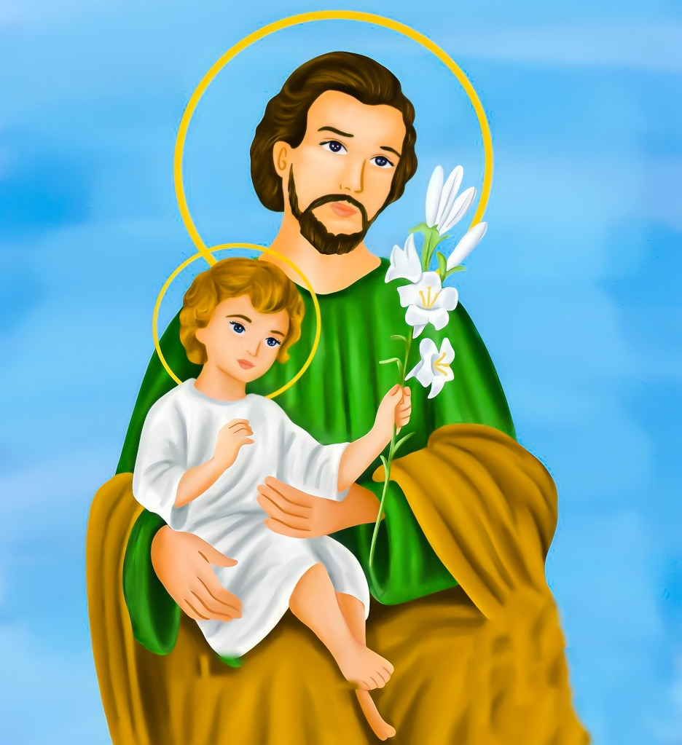

2023-2024

Sunday Faith Formation Handbook

6180 E. Willow Street, Long Beach, CA 90815



**2023-2024 St. Joseph Faith Formation Saint Walks**

St. Joseph Sunday Faith Formation Families will be invited to take a pilgrimage walk around the St. Joseph Parish Field to learn about the Saint of the Month. The Saint Walks will be from 9:30-10:00am and 11:15-1145am on the following days:

* Sunday, September 24, 2023: Mother Teresa
* Sunday, October 22, 2023: St. Pope John Paul the Great
* Sunday, November 12, 2023: St. Frances Xavier Cabrini
* Sunday, December 10, 2023: St. Lucy
* Sunday, January 21, 2024: St. John Bosco
* Sunday, February 4, 2024: St. Agatha
* Sunday, March 3, 2024: St. John of God
* Sunday, April 14, 2024: St. Bernadette



Dear Families:

The Faith Formation Staff of St. Joseph Parish welcomes you to our Children Faith Formation Programs. We are very pleased to have your children registered in our program, and we look forward to working closely with you and your children during this year. To serve with love – our faith formation programs live out our goals to welcome, provide spiritual nourishment, foster peace and justice, and encourage service to others.

Our mission is to deepen the students’ relationship with our loving, just and merciful God, to increase their knowledge of Faith and Church, to enrich their prayer practices and provide opportunities to serve the community. This is done primarily through classes, taught by Catechists, who are assisted by aides and parent volunteers. As your partners in the religious formation of your children, we strive to provide a welcoming, loving environment in which we can supplement what you are already teaching by your example.

It is our desire to assist you in the spiritual, as well as the education growth of your child, and ultimately your entire family. It is through prayer and active participation in the sacramental life of the Church that we can grow together and ensure that our children learn what it is to know and live the gospel message of Jesus Christ.

Although this year will offer challenges, we are excited to work with families to bring Jesus to our children. This year you will hear more about the domestic church (the smallest body of gathered believers in Christ) and how this can grow ever stronger in your own home!

We look forward to getting to know you better and we invite you to be an active participant in our faith formation programs as well as in the St. Joseph Catholic Community. We hope this “Parent Handbook” helps you become familiar with our program. **Please Read it carefully** and call me anytime regarding your child’s Faith Formation. On behalf of St. Joseph Parish, it is our pleasure to welcome you to the Faith Formation Program.

Yours in Christ,

St. Joseph Parish Faith Formation Team

**2023-2024 Faith Formation Sunday Program Parent Planner – Page 2**

FAMILY ATTENDANCE AT SUNDAY MASS: Parents have the responsibility of sharing their faith with their children and to bring them to Mass every Sunday in order to show them the importance of having God in their lives. Coming together as a family to Mass every Sunday is a faith obligation for all Catholic families, and a requirement of our faith formation program.

CLASS ATTENDANCE & ABSENCES: It is very important that your child attends class every week. If a child arrives later than 10 minutes after the class start time for Elementary and Jr. High Faith Formation Programs, he/she will be considered absent.

Sacrament Prep Students are allowed only FIVE (5) absences. If more than 5 classes/assignments are missed, the year will not count towards sacramental preparation. Please inform the RE office of any prolonged absence. We are always here to help. For Confirmation students, please refer to the Confirmation Parent Handbook.

If a child leaves the school campus without permission, the parents/guardians will be contacted and the police may be notified.

If a child needs to be dismissed early, the parent should write a note to the teacher indicating the time of release. Parent or parent designee, will pick up and sign the child out of the designated time.

COMMUNICATION: Each registered student will receive a weekly email with class assignments and links to additional materials. Please read all information. Always ask your children if they were given any papers that you need to read. From time to time, we will also send email reminders or updates. Please make sure your email address is current with the faith formation office.

VOLUNTEERS: All your children’s teachers are volunteers. Please keep them in your prayers and treat them as the precious gifts that they are to our Parish. We always need more aides in the classrooms. If you want to help, please call our Faith Formation Office.

VISITORS: We enjoy visitors in the classroom. However, in the interest of safety during possible catastrophes or emergencies, we NEED TO KNOW IN ADVANCE! A “minor” (in age) friend of your son or daughter must bring a parent’s note with an emergency phone number. We take responsibility for every student in the program.

BEHAVIOR:

1. Students should enter classrooms only if the volunteer Catechist is in the assigned classroom.

2. Students are expected to model their behavior after Jesus Christ who instituted two Great Commandants: “You shall love the Lord Your God with all your heart, and with all your soul, and with all your strength, and with all your mind; and your neighbor as yourself.” (Luke 11:27).

3. No food, drink or chewing gum inside the classroom unless it is an organized event by the catechist or Director of Faith Formation.

4. No electronic devices. Cell phones must be turned off and put away.

5. Behavior or language that intimidates, belittles, harasses (including harassment of a sexual nature), makes inappropriate references or physically harms oneself or others will result in disciplinary action. **We have a Zero Tolerance Bullying Policy.**

6. The Faith Formation program meets in the school classrooms, therefore going inside students’ desks is inappropriate. Each classroom has its own supply bin.

7. The following are some guidelines of behavior based upon these simple principles:

**A. Students properly respect and obey adults in authority.**

**B. Students properly respect the personal space and personal property of others.**

DISCIPLINE: In the event a student engages in inappropriate behavior any or all of the following may occur:

1. Parental notification of infraction.

2. Meeting between parents and Catechist and Director of Faith Formation.

3. Parent attendance required at subsequent program classes.

4. Temporary removal of student from Religious Education program.

5. Permanent removal of student from Religious Education program.

The Director of Faith Formation is responsible for ensuring that all sanctions against students are implemented in a fair and consistent manner by the faith formation catechists and staff.

ACCIDENTS: If a child is injured, a First Aid certified staff member or teacher will immediately attend to the student, administering first aid as needed and parents will be notified. If the injuries or condition of the student appears to be even remotely serious, 911 will be immediately called and parents will be notified.

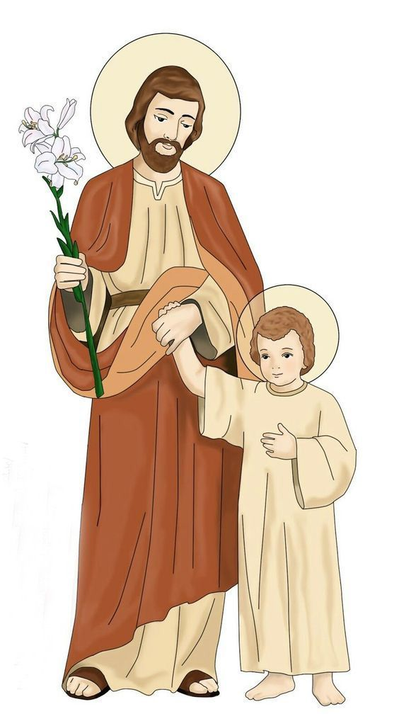

**FAITH FORMATION PROGRAM POLICIES**

**2023-2024 Faith Formation Sunday Program Parent Planner – Page 3**

**September 2023:**

17 1st CLASS

24 CLASS – Saint Walk: Mother Teresa

**October 2023:**

1 CLASS

8 CLASS

15 CLASS

22 CLASS – Saint Walk: Saint Pope John Paul the Great

29 CLASS

**November 2023:**

5 CLASS

12 CLASS – Saint Walk: Saint Frances Xavier Cabrini

19 NO CLASS – THANKSGIVING

26 NO CLASS – THANKSGIVING

**December 2023:**

3 CLASS – 1st Sunday of Advent

10 CLASS – Saint Walk: Saint Lucy / 2nd Sunday of Advent

17 CLASS – Las Posadas / 3rd Sunday of Advent

24 NO CLASS – CHRISTMAS EVE

31 NO CLASS – NEW YEARS EVE

**January 2024:**

7 CLASS

14 NO CLASS – MLK

21 CLASS – Saint Walk: Saint John Bosco

28 Empowering God’s Children (EGC)

**February 2024:**

4 CLASS – Saint Walk: Saint Agatha

11 CLASS

14 NO CLASS – ASH WEDNESDAY

18 NO CLASS – Presidents’ Weekend / 1st Sunday of Lent

25 CLASS – 2ND Sunday of Lent

**March 2024:**

3 CLASS – Saint Walk: Saint John of God / 3rd Sunday of Lent

10 CLASS – 4th Sunday of Lent

17 CLASS – 5th Sunday of Lent

24 CLASS – PALM SUNDAY

31 NO CLASS – EASTER

**April 2024:**

7 CLASS – Divine Mercy Sunday

14 CLASS – Saint Walk: Saint Bernadette

21 NO CLASS – 1ST COMMUNION RETREAT

28 LAST CLASS

**May 2024:**

5 St. Joseph Fair

12 MOTHER’S DAY

18 1st Holy Communion

19 1st Holy Communion

**EMPOWERING GOD’S CHILDREN:** The job of ensuring children’s safety is a challenging undertaking. The prevention of child sexual abuse requires we give our children the tools they need to overcome the advances of someone who intends to do them harm. The *Empowering God’s Children* program (EGC) is designed to assist parents and teachers in this important task. Your student will receive this training on: **January 28, 2024 @10:15-11:15am via zoom**.

**CLASS ATTENDANCE & ABSENCES:** It is very important that your child attends class/turns in assignments every week. If a child arrives later than 10 minutes after the class start time, he/she will be considered absent. Students are allowed only FIVE (5) absences during Sacramental Preparation years. If more than 5 classes are missed, the year will not count towards sacramental preparation. Please inform the Faith Formation Office of any prolonged absence. We are always here to help. See page 3 for our policies on leaving without permission or early dismissal.

**ARRIVAL / DISMISSAL:** Children should arrive no more than 10 minutes before class begins. No child should enter the classroom unless the teacher is present. No students will be allowed in after 10:10am. Children must be WALKED to their designated classroom in the St. Joseph School Buildings. Parents must sign their child into their classroom. *NO DROP-OFFS*. **FOR PICK UP, PARENTS MUST PARK** and sign out their child from the designated classroom… *NO EXCEPTIONS*!



**Elementary Faith Formation Program Sundays**

**Sacrament Prep 1 and Continuing Education (10-11:15am)**



Faith

Formation



**2023-2024 Faith Formation Sunday Program Parent Planner – Page 4**

**September 2023:**

17 1st CLASS

24 CLASS – Saint Walk: Mother Teresa

**October 2023:**

1 CLASS

8 CLASS

15 CLASS

22 CLASS – Saint Walk: Saint Pope John Paul the Great

29 CLASS

**November 2023:**

5 CLASS

12 CLASS – Saint Walk: Saint Frances Xavier Cabrini

19 NO CLASS – THANKSGIVING

26 NO CLASS – THANKSGIVING

**December 2023:**

3 CLASS – 1ST Sunday of Advent

10 CLASS – Saint Walk: Saint Lucy / 2nd Sunday of Advent

17 CLASS – Las Posadas / 3rd Sunday of Advent

24 NO CLASS – CHRISTMAS EVE

31 NO CLASS – NEW YEARS EVE

**January 2024:**

7 CLASS

14 NO CLASS –MLK

21 CLASS – Saint Walk: Saint John Bosco

28 Empowering God’s Children (EGC)

**February 2024:**

4 CLASS – Saint Walk: Saint Agatha

11 CLASS

14 NO CLASS – ASH WEDNESDAY

18 NO CLASS – Presidents’ Weekend / 1st Sunday of Lent

25 CLASS – 2ND Sunday of Lent

**March 2024:**

3 CLASS – Saint Walk: Saint John of God / 3rd Sunday of Lent

10 CLASS – 4th Sunday of Lent

17 CLASS – 5th Sunday of Lent

24 CLASS – PALM SUNDAY

31 NO CLASS – EASTER

**April 2024:**

7 CLASS – Divine Mercy Sunday

14 CLASS – Saint Walk: Saint Bernadette

21 NO CLASS – 1ST COMMUNION RETREAT

28 LAST CLASS

**May 2024:**

5 St. Joseph Fair

12 MOTHER’S DAY

18 1st Holy Communion

19 1st Holy Communion

**EMPOWERING GOD’S CHILDREN:** The job of ensuring children’s safety is a challenging undertaking. The prevention of child sexual abuse requires we give our children the tools they need to overcome the advances of someone who intends to do them harm. The *Empowering God’s Children* (EGC) program is designed to assist parents and teachers in this important task. Your student will receive this training on: **January 28, 2024 @10:15-11:15am via zoom**.

**PARENT SACRAMENT PREP 2 FORMATION:** We will offer two Sacrament Prep 2 Parent Only sessions via zoom from 7-8pm:

1st Reconciliation: TBD

1st Holy Communion: TBD

**SACRAMENT PREP 2 RETREATS:** We will offer two Sacrament Prep 2 retreats for parents and candidates:

Reconciliation Retreat:

TBD

First Communion Retreat:

Sunday, April 21, 2024: 1:30-4:30pm

**SACRAMENTS:**

First Reconciliation:

Saturday, February 10, 2024: 9:30-11:30am

First Communion:

Saturday, May 18, 2024: 10am & 5pm Mass

Sunday, May 19, 2024:

8:30am, 10:30am & 12:30pm Mass

**CLASS ATTENDANCE & ABSENCES:** It is very important that your child attends class/turns in assignments every week. If a child arrives later than 10 minutes after the class start time, he/she will be considered absent. Students are allowed only FIVE (5) absences during Sacramental Preparation years. If more than 5 classes are missed, the year will not count towards sacramental preparation. Please inform the Faith Formation Office of any prolonged absence. We are always here to help. See page 3 for our policies on leaving without permission or early dismissal.

**ARRIVAL / DISMISSAL:** Children should arrive no more than 10 minutes before class begins. No child should enter the classroom unless the teacher is present. No students will be allowed in after 10:10am. Children must be WALKED to their designated classroom in the St. Joseph School Buildings. Parents must sign their child into their classroom. *NO DROP-OFFS*. **FOR PICK UP, PARENTS MUST PARK** and sign out their child from the designated classroom… *NO EXCEPTIONS*!

**Elementary Faith Formation Program Sundays**

**Sacrament Prep Year 2 (10-11:15am)**

**2023-2024 Faith Formation Sunday Program Parent Planner – Page 5**



**PRAYER REQUIREMENTS**

**SIGN OF THE CROSS**

In the name of the Father, And of the Son,

And of the Holy Spirit

**HAIL MARY**

Hail Mary, full of Grace!

The Lord is with you;

Blessed are you among women,

And blessed is the fruit

Of your womb, Jesus.

Holy Mary Mother of God,

Pray for us sinners,

Now and at the hour of our death. Amen

**THE LORD’S PRAYER**

Our Father,

Who art in heaven,

Hallowed by thy name;

Thy kingdom come;

Thy will be done on earth as it is in heaven.

Give us this day our daily bread;

And forgive us our trespasses as

we forgive those who trespass against us;

And lead us not into temptation,

but deliver us from evil. Amen

**GLORY BE**

Glory be to the Father,

And to the Son,

And to the Holy Spirit.

As it was in the beginning, is now,

And ever shall be, world without end. Amen

**ACT OF CONTRITION**

O My God I am very sorry for all my sins

Because they displease you,

Who are all good and deserving of all my love. With your help, I will sin no more.

**SAFE GUARD THE CHILDREN**

Empowering God’s Children

The Archdiocese of Los Angeles is committed to compliance with the U.S. Bishops’ Charter for the Protection of Children and Young people. Article 12 of the Charter

mandates that “each diocese establish and maintain a Safe Environment Program for children and youth.” In light of this, the – VIRTUS Empowering God’s Children (EGC) – was adopted by the Archdiocese of Los Angeles in September, 2006. This program was implemented beginning January 2007, in parish Religious Education programs.

The children in St. Joseph Parish Faith Formation Programs, grades K-12, will participate in these lessons during the 2023-2024 program year. Check the program schedule for the date and time of your child(ren)’s training. Parent and guardians have an opportunity to review the program and materials at our Parent Commitment meeting.

All staff members, volunteers, and occasional helpers/chaperones whose duties require direct contact and supervision of young persons shall sign an agreement to follow the Guidelines for Adults Interacting with Young Persons at Parish Activities or Events (hereafter called Guidelines). Staff members, volunteers, and occasional helpers/chaperones may not interact with young persons on behalf of the parish until this agreement is signed.

All staff members and volunteers whose duties require direct contact and supervision of young persons shall complete the VIRTUS training, Protecting God’s Children, within four (4) months of beginning their ministry. Staff members and volunteers who have not yet completed this training may interact with young persons on behalf of the parish only if a VIRTUS trained adult staff member or volunteer is present. The ratio of untrained to trained staff members/volunteers shall not exceed 2 to 1 in any group setting.

**St. Joesph Parish Faith Formation**

**IMPORTANT CONTACT INFORMATION:**

**Office: (562) 598-0519**

Faith Formation Director: TBD

TBD

Faith Formation Assistant: Michelle Johnson

[michelle@stjosephlb.org](mailto:michelle@stjosephlb.org)

High School Confirmation & Youth Ministry: Liz Moreno

[Liz@stjosephlb.org](mailto:Liz@stjosephlb.org)

Adult OCIA: Fred and Susan Whitcraft / fredandsusan2001@yahoo.com



**Faith Formation Office Hours**

*Office will be closed all Parish Holidays*

Monday-Thursday: 9am-3pm

Friday-Saturday: Closed

Facebook:

[www.facebook.com/stjosephlbre](http://www.facebook.com/stjosephlbre)

Website:

[www.stjosephlb.org](http://www.stjosephlb.org)



**2023-2024 Faith Formation Sunday Program Parent Planner – Page 6**