Friday, April 5th Only
5:00 - 9:00 pm
St. Joseph Parish Fair

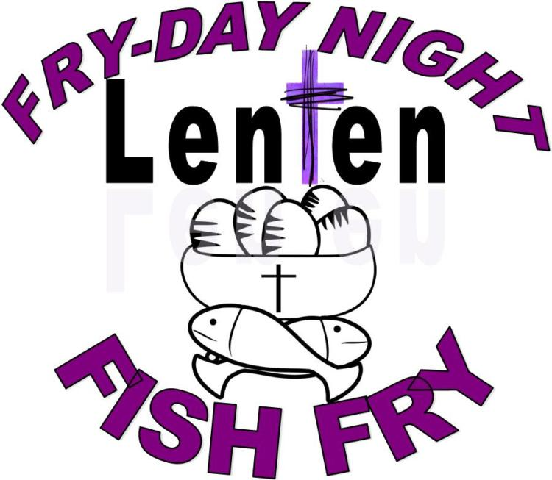

Pre-sale Plates:
Adult $10 …………………………… - 3 pieces of fish
Child $8 (10 & under) - 2 pieces of fish
Senior $8 (65 & over) - 2 pieces of fish

All Meals are served with French Fries and Coleslaw

*All Meals purchased at the fair will be $11 !!!
Dinner provided by Lions Club Seal Beach
70th year Anniversary

